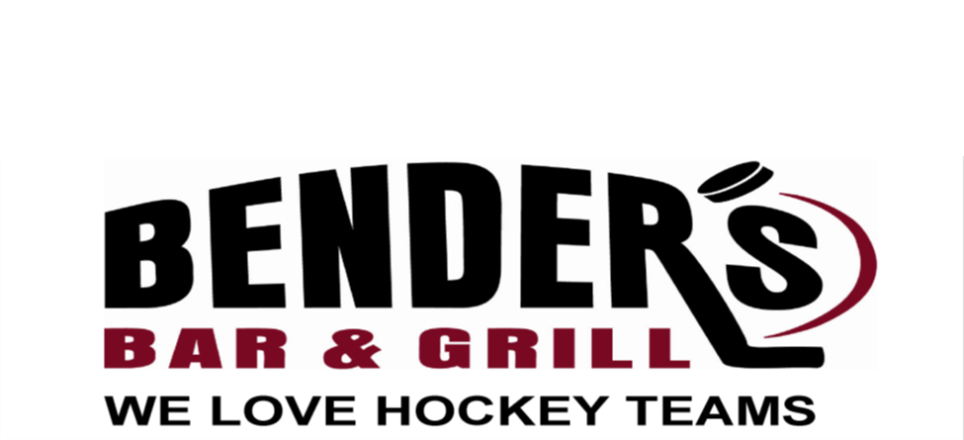
FULL RESTAURANT & BAR
Open Tuesday through Thursday at 4:00 pm &
Friday at 3:00
Open Saturday, & Sunday @ 9am for Breakfast
$3.50 domestic drafts
We have the Pac 12 Network, the Big Ten Network, the SEC Network and the NFL Sunday Ticket

303-974-5215 - benderssportsbar.com
Visit Benders with Your Team and Receive 10% Off! Team Buffets Available with Advance Notice

LOCATED ABOVE THE GREEN RINK OFF THE MAIN LOBBY

